COS 221 Practical 2

Scott Bebington

U21546216

**Task 1**

* User
* Parent/s
* Client
* ATM
* CIT
* FNB
* Branch
* Account

Task 2

* User()
* Parent/s()
* Client(Unique Number, Address, Names(First Name, Middle Name(optional), Surname), Age, Contact Details, Sex)
* ATM(Available Cash, Date and Time of last filling)
* CIT(Contract Start Date, Contract End Date)
* FNB()
* Branch(Unique Branch Code, Address, Contact Details, Open times, Close times, Closed Days, Open days)
* Account(Savings, cheque)

I believe there are some attributes that are lacking such as ID number for the client, contract number for CIT, FND needs to have a list of branch codes and client numbers, account needs to have an account number, ATM needs to have a branch code associated with it and a filled by attribute to see who last filled up on which date.

**Task 3**

For Client address, the address can be split up into street name, house number, postal code, suburb, city etc.

There can also be more than 1 branch location.

For Branch address, the address can be split up into street name, street number, name of shopping centre etc.

For client contact details, the contact details can be split up into multiple different types of contact methods such as whatsapp, direct phone calls, emails, Instagram handles, facebook username, discord username etc.

**Task 4**

The modal does not have any derived attributes, there would only de derived attributes if I were to add them into the modal.

**Task 5**

The middle name attribute for client may be null if the client has no middle name.

The sex attribute for client may be null if they chose to not provide their Gender.

**Task 6**

6.1) My modal currently does not allow for the introduction of a Sharia-compliant 32-day savings account, I would have to adapt my modal to include an investment date into the savings account, and investment amount and a percentage profit based on investment amount. All inline with Sharia financial law.

6.2) My modal would allow for the introduction of USD as the cheque and savings account has no restriction on what currency it holds.

6.3) My modal does allow for the use of multiple contact methods as mentioned in task 3 where I mentioned that the contact details may be many different types.

6.4) I think the bank should verify ID number as well as the contact details to ensure they have the correct client accessing information, my modal does account for this as I have added an ID field to the client entity and it already has a contact details section.

**Task 7**

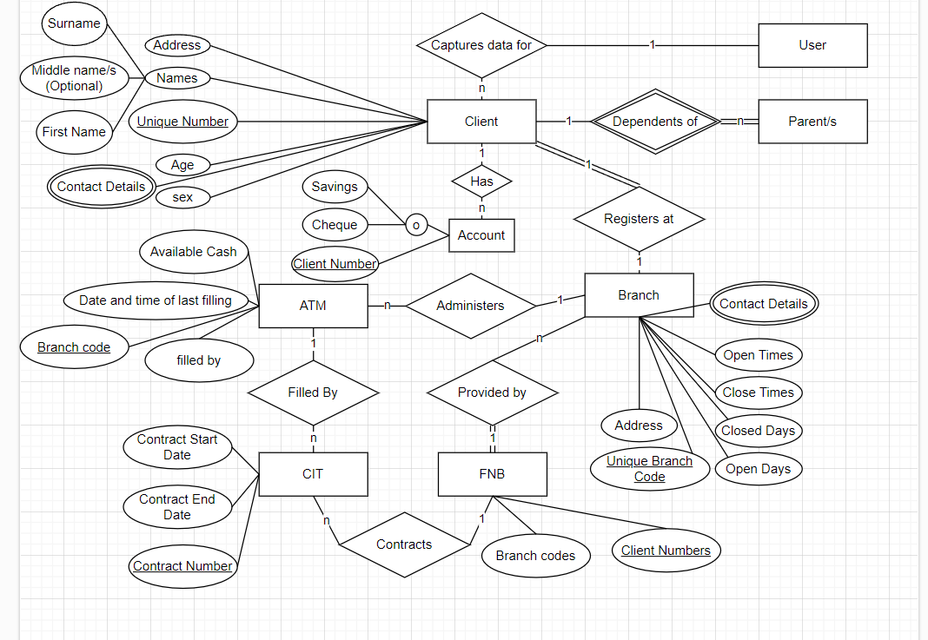

**Task 8**

Step 1: Step 1: Mapping of Regular Entity Types

Creating relations for each strong entity type.

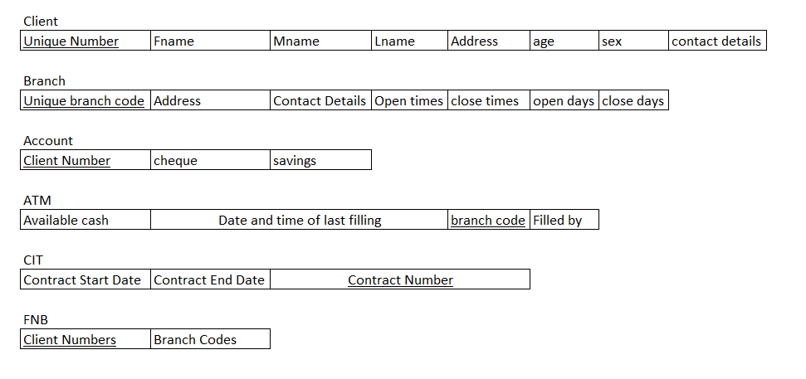

Step 2: Mapping of Weak Entity Types

Adding in relations for each weak entity type.

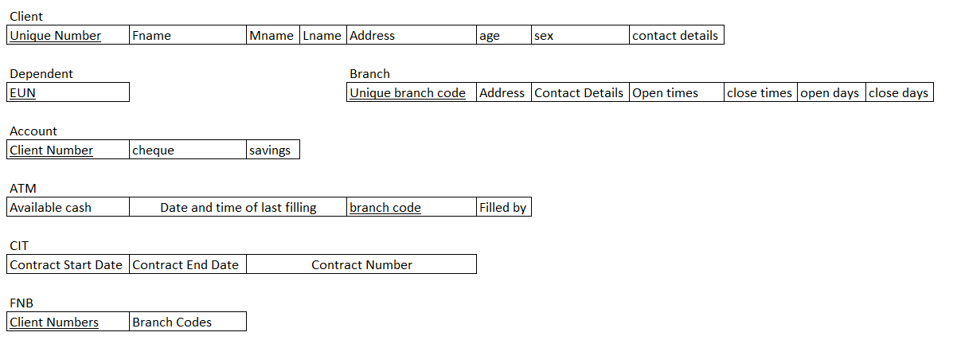

Step 3: Mapping of Binary 1:1 Relationship Types

Creating links between all the 1:1 relationships.

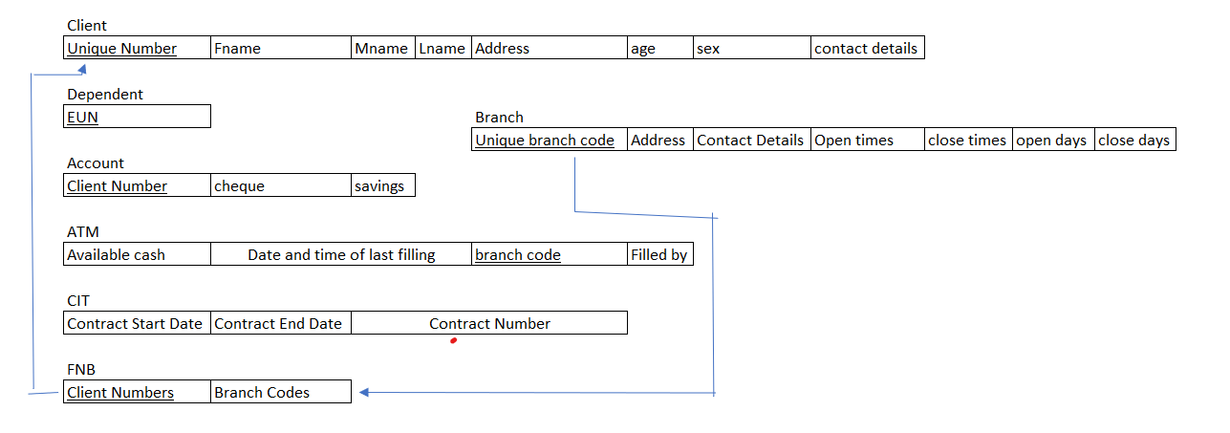

Step 4: Mapping of Binary 1:N Relationship Types.

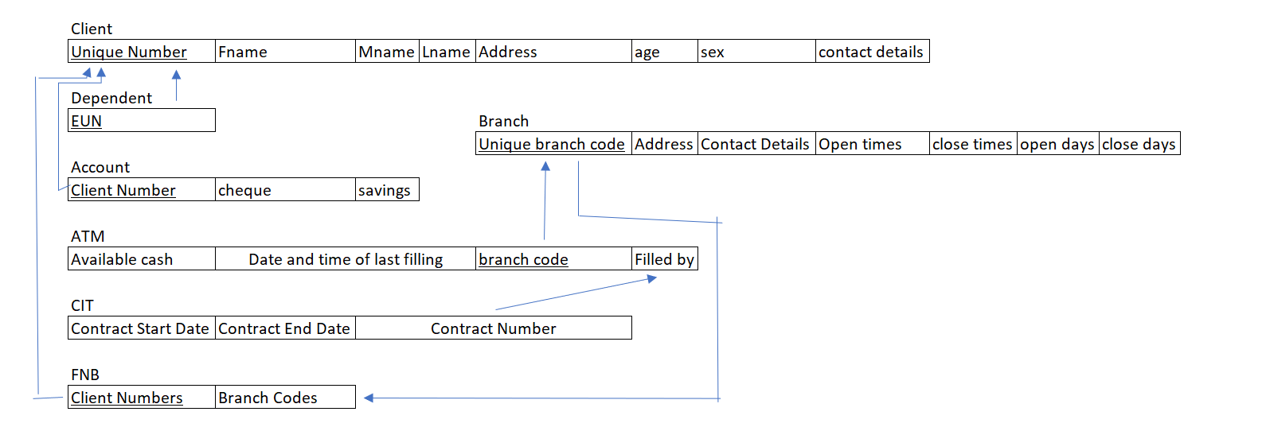

Step 5: Mapping of Binary M:N Relationship Types.

My modal has no M:N relations.

Step 6: Mapping of Multivalued Attributes.

Names is split up into Fname, Mname and Lname.



Step 7



Client: Unique Number(Integer), Fname (String), Mname(String), Lname(String), Address(String), Age(Integer), Sex(Char), Contact Details(String)

Dependent: EUN(Integer)

Account: Client Number(Integer), Cheque(Boolean), Savings(Boolean)

ATM: Available cash(Integer), Date and Time of last filling(Date), Branch Code(Integer), Filled by(integer)

CIT: Contract Start Date(Date), Contract End Date(Date), Contract Number(Integer)

FNB: Client Number(Integer), Branch Codes(Integer)

Branch: Unique Branch code(Integer), Address(String), Contact Details (String), Open Times(Time), close Times(Time), Open Days(Date), Close Days(Date)